Lab 7: Complete Procurement Flow

In this lab, you will add Next best skills to the previously created [Your Name] RAG (lab 5) skill flow and [Your Name] Initiate Replenishment skill flow.

1. **Add Next best skills to the [Your Name] RAG skill flow**
   1. Click on Skills and apps from the main page.

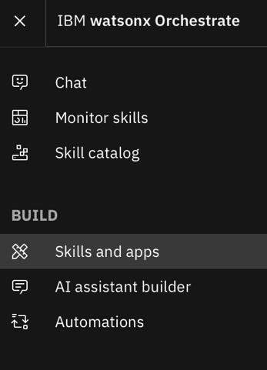

* 1. Go to Skills and search for the [Your Name] RAG skill, click on Enhance this skill as shown below.

* 1. Click on Next best skills.

* 1. Click on + to add the next best skill, search for [Your Name] Initiate replenishment skill and click on add skill.

* 1. Click on Publish button to publish the skill.

1. **Add Next best skills to the [Your Name] Initiate Replenishment skill flow**
   1. Add “Send Email” as personal skills.

**\*\*If you’ve added the Microsoft Outlook, Send Email skill in your personal skill, you can skip this step.**

* + 1. Click on Skill catalog and Add skill for “Send an email using Outlook” A screenshot of a computer

       Description automatically generated
    2. On the search bar, search for outlook and click on the “Microsoft Outlook” tile.

* + 1. Click on the “Connect App” button on the top left. A blue rectangular sign with white text

       Description automatically generated
    2. Change “Non-admin user” to “Admin user” and click on Connect App

* + 1. Click on the following link

* + 1. Refer to the connection details sheet and look for Microsoft Outlook log in details.
  1. Click on Skills and apps from the main page.

* 1. Go to Skills and search for the [Your Name] Initiate Replenishment skill, click on Enhance this skill as shown below.

* 1. Go to Next best skills.

* 1. Search for send an email skill and add the skill.

* + 1. Click on the send an email skill. Click on body.Content box and select [Your name] Initiate Replenishment from the dropdown. Then select Email Content from the next dropdown.

* + 1. Select Publish.

1. **Use the Skill flow**
   1. Select RAG skill flow for using the skill flow. Add a user question “What are Procurement Requisition (PR) rules ?” and select Apply.

* 1. Watson Discovery skill is triggered and some of the parameters are pre filled in the form. Click on Apply.

* 1. Watson Discovery returns relevant passages for the User Question. Select the option and click on Apply.

* 1. Content Generation flow is triggered and based on the relevant chunk, the prompt gets populated. Select Apply.

* 1. An answer will be generated based on the provided paramters and the user question.

* 1. You will see the following next best action, click on [Your Name] Initial Replenishment.

* 1. The first skill in the skill flow will be automatically triggered. Click Apply.

* 1. Once the result is out, select the result and click Apply.

This will automatically trigger the Reorder Quantity skill.

* 1. Once the result is out, Select an Order date and click Apply.

* 1. The output shows the forecasted amount and current inventory as below. click Apply to proceed. This will return the reorder_quantity.A screenshot of a computer

     Description automatically generated

* + 1. You will immediately see the “Get Lowest Supplier skill”, with the Product Name filled. Click Apply.

* 1. Once the result is returned, you are free to choose any supplier you want and Click Apply.

3.12 The output will be shown as such, click on Apply

3.13 The output will be shown as below. Refer to the displayed OrderQty and CostPerUnit and Type in the OrderQty in OrderQtyStr and CostPerunit in CostPerUnitStr input boxes.

3.13.1 Type any reason in the ‘Reason’ input box such as “festivities around corner” and click on Apply.

3.14 The final output is shown as such:

* 1. Insert your name in the Email Content and click on Apply. You will see the following next best action, click on send an email.

3.16 The following output is shown:

3.17 Fill in all the fields and click on Apply to send the mail.